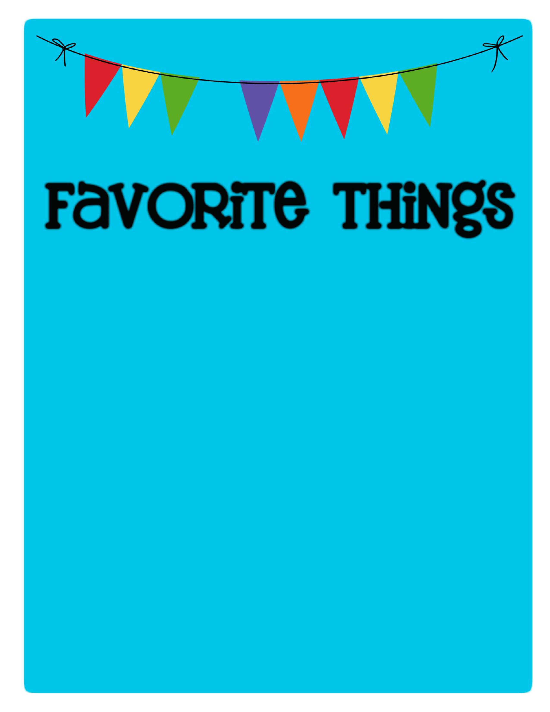

Name: Maison Marcou _________________________

Birthday: _August 5th

Favorites

Places to Eat: _Chipotle

Places to Shop:

_ Target

Favorite Gift Cards:_ Target, Starbucks

Drinks :

Starbucks

:

Strawberry Acai Refresher

Sonic

:

_Blue Raspberry Slush_________

Other

:

__________________________________________

Scents (lotion, Scentsy, etc.): Lavender

Candy/Snacks: Hershey’s Cookies & Cream, Sour Gummy Worms takis________________________________

Cookies/Cake: Chocolate Chips Cookies

Flowers

:

____

Peonies

Hobbies/Collectibles: __________

Other Wish List Items: ___________